29/09/22

What is animation?

* Animation is a medium of storytelling narrative
* Animation is the illusion of movement

Animation generally consists of 24/25 frames a second – better quality usually consists of up to 60 frames a second

Mini movies:

1. A colour box by Len lye

* Really strange
* Kind of like cells, biology
* Lots of colours
* They were kind of dancing to the music

1. (Stop motion) factual conversations: dimensions of a dialogue by Jan svankmajer

* Uncomfortable
* Mildly horrifying
* Depicts arguments, disagreements, an unhealthy relationships where neither party listens to the other and talks over one another, not communicating properly, just trying to get their point across without listening to each other.

Why are you here?

* To make people hear me

To watch:

Caterpillar-plasty by David Barlow

Animators:

* Christoff Niemann
* Virginia mori
* Georges schwitzgetel
* Sebastian laudenbauch
* Ladislas starkvich
* Michael dudock duwit
* Ng ’endo mukki
* Vanessa bell
* Martin parr
* Cindy Sherman
* Don McCullin

06/10/22

This is pig meat - Peter Millard

* Very strange
* Lots of textures and colours
* Tells a story through stop motion

Narrative choices are framing choices. All art is a response to something. ‘In the place called lost strange things are found’

What is an image?

* Images has artefact
* something of value
* a way of expressing your views of the world

An image can be:

* + A representation
  + Temporal/time related: something that can outlast what it seeks to represent
  + A contract between viewer and maker
  + A signature
  + A mark
  + Something constructed or composed
  + A story
  + A point of view/perspective
  + A thing that exists in the mind of viewer and maker
  + A truth
  + A language

To look is an act of choice - we never look at just one thing, we are always looking at the relation between things and ourselves. Every image embodies a way of seeing

How do they communicate ‘information’ and tell stories? How are they shaped by the contexts in which they are made, and the materials and tools used? What value do they have? What power do they have? what effects can they have on people that consume them and on society as a whole? How do they shape our attitudes to each other, and our sense of ourselves, our identities?

What kinds of meaning do they have and who gives them meaning – the people that create them or the people that view them, appropriate them, and remake and interpret them? In all images, things are included, and things are excluded, and the world is presented in a particular way. These choices are never neutral.

Your vision: to know what you’re going to draw you have to begin drawing. What are you curious about what are you uncertain about?

What catches your eye?

Consider:

* Point of view
* Language
* Authority
* Choreography
* Storytelling

Is the language consistent? Is there a clear sense of authorship? Of story? Of something indefinable but seductive: a truth/a reaching/a rawness? A kind of living spark that runs under the collection.

Every time you make a choice, whether consciously or subconsciously you place a value on the work.

A man and his dog out for air – Robert Breer

* Shows what sound feels like

Visit a gallery or other venue/spaces around London and find work by artists who use objects in their work – perhaps to tell a story or place with memories, subvert meaning, reframe the familiar, reflect on their culture, on history etc. they must be photographers, painters, printmakers, sculptors etc.

Sketch, note, record, document.

Be prepared to say something about how they moved or challenged you.

Give a short summary of the artists background, their themes, techniques, etc, what they’re trying to communicate or engage with in their work?

Tell us why you have chosen this artist and why you have responded as you did.

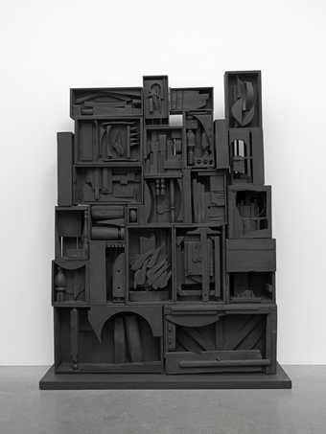I went to the Tate modern too see if anything there would move me when I saw ‘the black wall’ sculpture by Louise Nevelson. she uses objects that she found around New York city in order to create a piece that she can create a narrative with. This piece made me stop and look at it. I felt drawn to it. It seems to represent how chaos and discord can be rearranged into something with order and meaning, and a purpose other then what it was made for. The fact that everything is painted black in order to match each other reflects how we change parts of ourselves in order to fit in with the society around us.

Louise Nevelson was born in the Poltava governorate of the Russian empire, but she lived in Manhattan with her family. This sculpture reflects her habit of being a collector and her connection to the neighbourhood of Manhattan. She would collect objects that she found and has incorporated them into her sculptures in different ways. Her dramatic sculptures paved the way for female artists as she showed that it wasn’t only men’s artwork that could be large scale.